Partner Symposiums Report
Our Lord’s commission is to go and make disciples (Matthew 28:19-20). To respond to this commission, justBible Ministries has been conducting Symposiums in Uganda and Kenya since 2014. These Symposiums are a three-day teaching through a book of the Bible. Since 2014 we have taught through eight books of the Bible (Joshua, James, Galatians, Ephesians, 1 John, Mark, 1 Peter, and Colossians). Attendees of these Symposiums receive a study workbook (translated in Luganda or Swahili) and a Bible if they never owned one.
Resources and training are extremely challenging to nonexistent for most Africans. The intent of the Symposium is to provide Bible teaching supported by a study resource and the Word of God in their local language. The multiplication of disciples occurs when the attendees return to their villages and use what they obtained to teach in their church and community. At our 2025 International Symposium, eight different countries’ representatives were in attendance.
Recognizing the need for pastors to learn how to study the Bible, we developed a “Bible Study Technique” training using the book of Malachi. We held this training in 2019 and 2023 in Seeta Nazigo, Uganda, and virtually in April 2025 with pastors in Nairobi, Kenya. We have commissioned forty (40) pastors who have completed this training.
There are two key pastor partners we have established to be the “in-country” coordinators and managers of the expanded teaching. Pastor David Musoke from Seeta Nazigo, Uganda and Pastor Maurice Adum from Nairobi, Kenya have been instrumental in holding “Partner Symposiums.” This is where the commissioned pastors utilize the workbooks to make disciples and teach the Word of God.
In March 2025, seven (7) simultaneous Partner Symposiums were held in remote villages in Uganda coordinated by Pastor David Musoke. Twelve (12) commissioned pastors conducted these Partner Symposiums teaching the book of James. Three hundred (300) workbooks were printed and provided to the attendees.
Pastor Maurice’s approach was to hold Partner Symposiums every month at different locations.
Below shows the month and location of these Partner Symposiums:
January 2025 | Goma, DRC Congo | February 2025 | Nyamongo, Tanzania
March 2025 | Busia, Kenya | April 2025 | Nairobi, Kenya
May 2025 | Arusha, Tanzania | June 2025 | Kahama, Tanzania
July 2025 | Palisa, Uganda | August 2025 | Koboko, South Sudan
September 2025  November 2025 | Karangwe, Tanzania  Bujumbua, Burundi | October 2025  December 2025 | Gulu, Uganda  Mombasa, Kenya

Two thousand (2,000) workbooks of 1 John and 1 Peter have been printed and provided to the attendees of these Partner Symposiums.
The Partner Symposiums coordinated by Pastor David Musoke in 2025 required a budget of $2,500. Each monthly Partner Symposium coordinated by Pastor Maurice Adum averaged $1,000. In 2025, the Lord provided funds of $14,500 for these Partner Symposiums.
This map below shows the locations of all the Partner Symposiums:
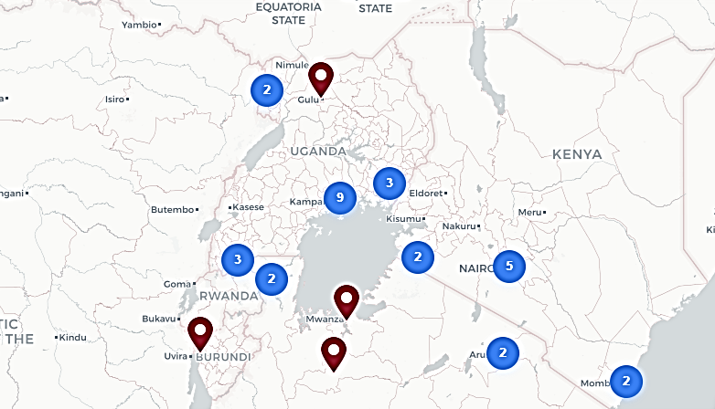
Through Partner Symposiums many people have been resourced and taught the Word of God. Our partners in Uganda and Kenya have expanded discipleship resourcing into villages and communities beyond the reach of the capability of any “missionary.” Imagine the impact of 2000 individuals having the capability to now study the love and fellowship 1 John teaches and the perseverance in the faith 1 Peter conveys. God’s discipleship commission is being accomplished.
As we look forward to how the Lord is expanding our efforts to disciple multiple pastors in various countries, the need has substantially increased. Pastor David Musoke will again coordinate Partner Symposiums in 2026. Pastor Maurice Adum has developed his plans for monthly Partner Symposiums in 2026. Since the Bible Study Techniques training in April (in Nairobi) there are several commissioned pastors working with Pastor Maurice to hold their own independent Partner Symposiums. The current budget for Partner Symposiums in 2026 is $20,000. This budget includes the growth of Partner Symposiums which will be conducted by three additional commissioned pastors. We are projecting 3500 attendees across east Africa to be discipled through these Partner Symposiums in 2026.
The Lord uses His people to support His discipleship commission. Please consider supporting our partners in Uganda and Kenya as they are fulfilling the Lords commission.

